

**Hospital Management System**

Submitted to the

Department of Statistics and Computer Science

Moi University

in Partial Fulfillment of

the Requirements for the Degree of

Bachelor of Science in Computer Science

*By*

Reg No. *Name*

1. COM/04/15 FAITH SYOKAU JULIUS
2. C0M/08/15 LANG’AT KIKWEI WILLIAM
3. C0M/11/15 MATUKU JOSHUA MUTINDA
4. COM/1001/15 LAWRENCE LANGAT
5. COM/1023/15 SHADRACK KANGOGO KIPRONO

**Declaration**

We declare that this report is our original work and has not been presented for a degree award in any other university. No part of this work may be reproduced without prior written permission of the authors and/or Moi University.

*COM/04/15 Faith Syokau Julius Signature………… Date………….*

*COM/08/15 Lang’at Kikwei William Signature………… Date…………*

*COM/11/15 Matuku Joshua Mutinda Signature……….. Date…………*

*COM/1001/15 Lawrence Langat Signature……….. Date………….*

*COM/1023/15 Shadrack Kangogo Kiprono Signature………. Date………….*

**Approval**

**Supervisor’s Declaration**

This project has been submitted for review with my approval as the University Supervisor.

Signature…………………………………………Date ……………………………

Name:. …………………………………………………………………………………….

DEPARTMENT OF STATISTICS AND COMPUTER SCIENCE

MOI UNIVERSITY

**Dedication**

The satisfaction that accompanies the successful completion of this project would be incomplete without the mention of people whose ceaseless cooperation , guidance and encouragement made it a success. We are grateful to our project supervisor Mr. Ernest Kiprop for the guidance, inspiration and constructive suggestions that helped us in the preparation of this project.

**Abstract**

The Hospital Operations System provides the benefits of streamlined operations, enhanced administration & control and superior patient care. It is powerful, flexible, and easy to use and is designed and developed to deliver very many benefits to hospitals.

The project ‘Hospital Operations System’ is a web based system which employs proper client and server side techniques. The system uses MySQL Database Management System for records storage.The MySQL DBMS is one of the best and the easiest software to keep information. This system uses HTML ,CSS, Twitter Bootstrap , Javascript , jQuery and jQuery UI for the front-end , PHP and SQL for the backend . The Entire application is web based .The database of the system makes it more user friendly and expandable.

The Hospital Operations System is built to meet the specific requirements of the mid and large size hospitals . All the required modules and features have been particularly built to fit to user requirements. The package is highly customizable and can be modified as per the needs and requirements of different hospitals. Prolonged study of the functionalities of the hospital and its specific requirement has given it a wonderful shape both technically and usability . It covers all the required modules right from the Reception, Consultation, Ward, Pharmacy , Laboratory ,Admin and Mortuary Departments .

**Keywords and Phrases**

* HOS –Hospital Operations System
* DBMS –Database Management System

**1. Introduction and Background**

1.1 Statement of Problem Area (brief, non­technical)

1.2 Background

1.3 Brief Project Description (overview of new, extended or different functions, structure or operation)

1.4 Purpose/Objectives/justification of Project (theoretical, practical, or educational impacts on hardware, software, or users)

**2. Literature Review**

2.1 Previous and Current Work, Methods and Procedures (representative)

**3. System Functional Specification**

3.1 Functions Performed (itemize and describe)

3.2 User Interface Design

(Include User Input Preview and User Output Preview)

3.3 System Data Base/File Structure Preview

3.4 External and Internal Limitations and Restrictions

3.5 User Interface Specification

3.6.1 User Screens/Dialog

3.6.2 Report Formats/Sample Data

3.6.3 On­line Help Material (if applicable)

3.6.4 Error Conditions and System Messages

3.6.6 Control Functions

**4. System Performance Requirements**

4.1 Efficiency (speed, size, peripheral device usage)

* 1. Reliability

4.2.1 Description of Reliability Measures (accuracy, precision, consistency, reproducibility, etc.)

4.2.2 Error/Failure Detection and Recovery (failure modes, failure consequences, error logging and reporting, manual and automatic recovery procedures)

4.2.3 Allowable/Acceptable Error/Failure Rate

4.3 Security

4.3.1 Hardware Security

4.3.2 Software Security

4.3.3 Data Security

4.3.4 Execution Security (user validation)

4.4 Maintainability

4.5 Modifiability

4.6 Portability

**5. System Design Overview**

5.1 System Data Flow Diagrams

5.2 System Architecture and Structure

5.3 System Data Dictionary

5.4 Description of System Operation (high level)

5.5 Equipment Configuration (diagram and description)

5.6 Implementation Languages (which and why)

5.7 Required Support Software (pre­existing)

**6. System Data Structure Specifications**

6.1 User Input Specification

6.1.1 Identification of Input Data

6.1.2 Source of Input Data (NOT input device)

6.1.3 Input Medium and/or Device

6.1.4 Data Format/Syntax

6.2 User Output Specification

6.2.1 Identification of Output Data

6.2.2 Output Medium and/or Device

6.2.3 Output Format/Syntax

6.2.4 Output Interpretation (meaning of output)

6.3 System Data Base/File Structure Specification

6.3.1 Identification of Data Base/Files

6.3.2 (Sub)systems Accessing the Data Base (creating, updating, using;

frequency)

6.3.3 Logical File Structure (record formats, file organization, access

methods, rationale)

6.3.4 Physical File Structure (storage device, organization,

access, etc.)

6.3.5 Data Base Management Subsystems Used (internal or external)

7. **Module Design specifications (at least 5 modules)**

7.1 {Provide *Module Name Here*}

7.1.1 Module Functional specification

* + - * + Functions Performed
        + Module Interface Specifications (input/output arguments/global variables/files)
        + Module Limitations and Restrictions

7.1.2 Module operational Specification

* + Locally Declared Data Specifications (variable dictionary)
  + Algorithm Specification (flowchart, pseudocode, decision table, etc)
  + Description of Module Operation

**8. System Verification**

8.1 Items/Functions to be Tested

8.2 Description of Test Cases

8.3 Justification of Test Cases

8.4 Test Run Procedures and Results

8.5 Discussion of Test Results

**9. Conclusions**

9.1 Summary

9.2 Problems Encountered and Solved

9.3 Suggestions for Better Approaches Problem /Future Extensions to Project

**10. Bibliography**

USE APA FORMAT

**11. Appendices**

**12. Program Listings (*place the code for the modules described in chapter 7 here*)**

1. **User Manual**

# INTRODUCTION AND BACKGROUND

## 1.1 Problem Statement

Most of the hospitals today still carry out most of their day to day operations manually. The day to day operations of an hospital involve keeping of patients ,staff and other different types of records. However , the manual record keeping has various drawbacks . These drawbacks include :

**Lack of immediate retrievals: -**The information is very difficult to retrieve and to find particular information like- E.g. - To find out about the patient’s history, the user has to go through various registers. This results in inconvenience and wastage of time.

**Lack of immediate information storage: -** The information generated by various transactions takes time and efforts to be stored at right place.

**Lack of prompt updating: -** Various changes to information like patiendetails or immunization details of child are difficult to make as paper work is

involved.

**Error prone manual calculation: -** Manual calculations are error prone and

take a lot of time this may result in incorrect information. For example

calculation of patient’s bill based on various treatments.

**Preparation of accurate and prompt reports: -** This becomes a difficult

task as information is difficult to collect from various registers.

**Lack of security for the records** since anyone can disarrange the records of the manual system .

To maintain the records manually is time-consuming .

## Background of study.

A Hospital is a place where Patients come up for general disease treatment. Hospitals provide facilities like:-

* Diagnosis for diseases.
* Disease treatment facilities.
* Facility for admitting Patients (providing beds, nursing, medicines etc.)
* Immunization for Patients/Children.

Various operational works that are done in a Hospital are:-

* Recording information about the Patients that come.
* Recording information related to diagnosis given to Patients.
* Keeping medical record of the treatment provided to patients.
* Keeping information about various diseases ,tests and medicines available to cure

them.

These are the various jobs that need to be done in a Hospital by the operational staff and

Doctors. All these works are done on papers. The work is done as follows:-

* Information about Patients is done by just writing the Patients name, age and

gender. Whenever the Patient comes up his information is stored freshly.

* Diagnosis information to patients is generally recorded on the document, which

contains Patient information. It is destroyed after some time period to decrease

the paper load in the office.

* Information about various diseases is not kept as any document. Doctors

themselves do this job by remembering various medicines.

All this work is done manually by the receptionist and other operational staff and lot of

papers are needed to be handled and taken care of. Doctors have to remember various

medicines available for diagnosis and sometimes miss better alternatives as they can’t

remember them at that time.

## Brief Project Description

This Hospital Operations System provides online record storage , updates and retrieval facility. This system promises very less or no paper work and also provides help to Doctor and operational staff. In this system everything is stored electronically so very less amount of paper work is required and information can be retrieved very easily without searching records from different registers.

## Objective of the Project

Hospitals are essential part of our lives, providing medical facilities to people suffering from various ailments. It is necessary for the hospitals to keep track of its day-to-day activities and records of its patients and staff personnel in the hospital.

But keeping track of all the activities and their records on paper is very cumbersome and error prone. It is also very inefficient and time-consuming process due to the continuous increase in population and number of people visiting the hospitals. Recording and maintaining all these records is highly unreliable, inefficient and error-prone. It is also not economically and technically feasible to maintain these records on paper.

Thus keeping the working of the manual system as the basis of our project, we developed an automated version of the manual system, “The Hospital Operations System”.

The main aim of our project is to provide a paper-less hospital up to 90%. The system also provides excellent security of data at every level of user-system interaction and also provides robust and reliable storage and backup facilities.

# LITERATURE REVIEW

The Hospital Operations System provides the benefits of streamlined operations, enhanced administration and superior patient care.HOS is powerful, flexible, and easy to use and is designed and developed to deliver real conceivable benefits to hospitals. This HOS is designed for multispecialty hospitals, to cover a wide range of hospital administration and management processes. It is an integrated end-to-end Hospital Operations System that provides relevant information across the hospital to support effective decision making for patient care and hospital administration in a seamless flow.

A Hospital is a place where Patients come up for general diseases. Hospitals provide

facilities like:-

* Consultation by Doctors on Diseases.
* Diagnosis for diseases.
* Providing treatment facility.
* Facility for admitting Patients .

Various operational works that are done in a Hospital are:-

* Recording information about the Patients that come.
* Recording information related to diagnosis given to Patients.
* Keeping medical records of the treatment provided to patients.
* Keeping information about various diseases and medicines available to cure them.

These are the various jobs that need to be done in a Hospital by the operational staff and

Doctors. All these works are done on papers. The work is done as follows:-

* Information about Patients is done by just writing the Patients name, age and gender. Whenever the Patient comes again his/her information is stored freshly.
* Diagnosis information to patients is generally recorded on the document, which contains Patient information. It is destroyed after some time period to decrease the paper load in the office.
* Medical records for patients are maintained in pre-formatted sheets, which are kept in a file.
* Information about various diseases is not kept as any document. Doctors themselves do this job by remembering various medicines.

All this work is done manually by the receptionist and other operational staff and lot of

papers are needed to be handled and taken care of. Doctors have to remember various

medicines available for diagnosis and sometimes miss better alternatives as they can’t

remember them at that time.

The limited time and resources have restricted us to incorporate, in this project, only main activities that are performed in a Hospital Operations System, but utmost care has been taken to make the system efficient and user friendly. “Hospital Operations System” has been designed to computerize the following functions that are performed by the system:

1. Online Registration of patients
2. Interdepartmental forwarding of patients details during treatment process
3. Statement of Patient Details

i) Admitted Patients

ii) Discharged Patient

iii) Patients treatment history

1. Drug Management

i)Registration of new drug into the system

ii)Update Drug records

iii) View available drugs

1. Management functionality
2. Management of doctors and operational staff
3. Generation of diseases and drug reports.

6.Mortuary management

1. Storage of the deceased records.
2. Discharge of the deceased.

# SYSTEM FUNCTIONAL SPECIFICATION

## Functions Performed by the system

1. Registration of patients online

Registration of patients takes place at the hospital’s reception department. On registration, a patient is issued with a unique card number that is used to identify the patient in the various department. If the patient had already visited the hospital before and got registered , the receptionist is able to search the patient’s details and forward them to the doctor (Consultation department).

1. The doctor can view unattended patients as registered by the receptionist and diagnose them

The doctor can search and select an unattended patient from a list of unattended patients. A selected patient is diagnosed . The results of the diagnoses are forwarded to the relevant department. This can be either the lab department , pharmacy department or ward department.

1. Viewing of laboratory tests and posting of laboratory results.

The laboratory department staff is able to view unattended patients’ laboratory tests as posted by the doctor from the consultation department. He/she can then carry out the specified patient’s tests and post back the results to the doctor.

1. Viewing of available drugs in the hospital.
2. Viewing of drugs to be issued to the patient by the pharmacist as posted by the consultant and issuing the specified drugs to the patient if the drugs are available.
3. Generation of disease and drug reports for a specific period as specified.
4. Update and registration of new drugs- In case of a new drug in the hospital, its details are entered into the system. The amount of an existing drug can as well be updated.
5. Admission and discharge of patients online – patients are admitted at the ward department. The system can also discharge admitted patients.
6. Registration and discharge of the deceased.

## User Interface Design

The user interface consists of a set of menus through which the user can interact with data on

the bandari server. These menus include Homepage menu, a Management Department menu, a Consultation Department menu, a Ward Department menu, a Reception Department menu, a Pharmacy Department menu , a Laboratory Department menu and a Mortuary Department menu.

Each menu consists of various GUI components, such as buttons, labels, icons and text fields. These components will be arranged in such a way that the user will be able to quickly grasp the purpose of each menu and perform whatever task it is designed for efficiently.

The next several pages describe and illustrate the following menus:

* Homepage Menu
* Management login
* Staff login
* Management Menu
* Reception Menu
* Consultation Menu
* Pharmacy Menu
* Laboratory Menu
* Mortuary Menu

1.HOME PAGE.

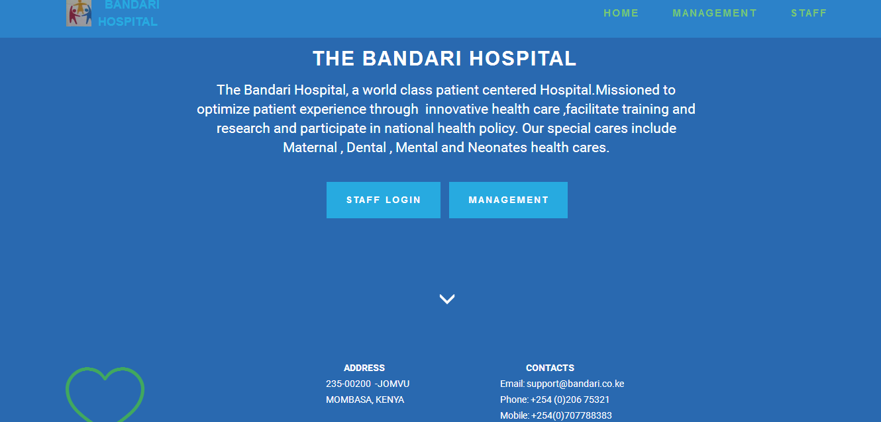

The first time a user loads The Bandari Hospital Operations ,the Homepage shown above is displayed. The user , who may be the be the administrator (management) or staff , chooses from the navigation a login page . The administrator has their own login page named “MANAGEMENT” in the navigation while all staff use the same login page named “STAFF” in the navigation menu from which they are redirected to their specific departments depending on login details entered.

2.MANAGEMENT LOGIN PAGE

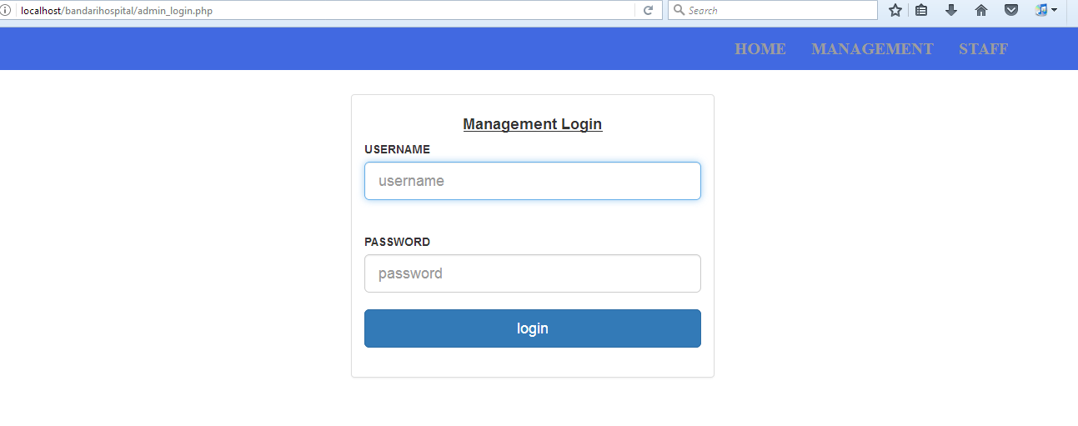

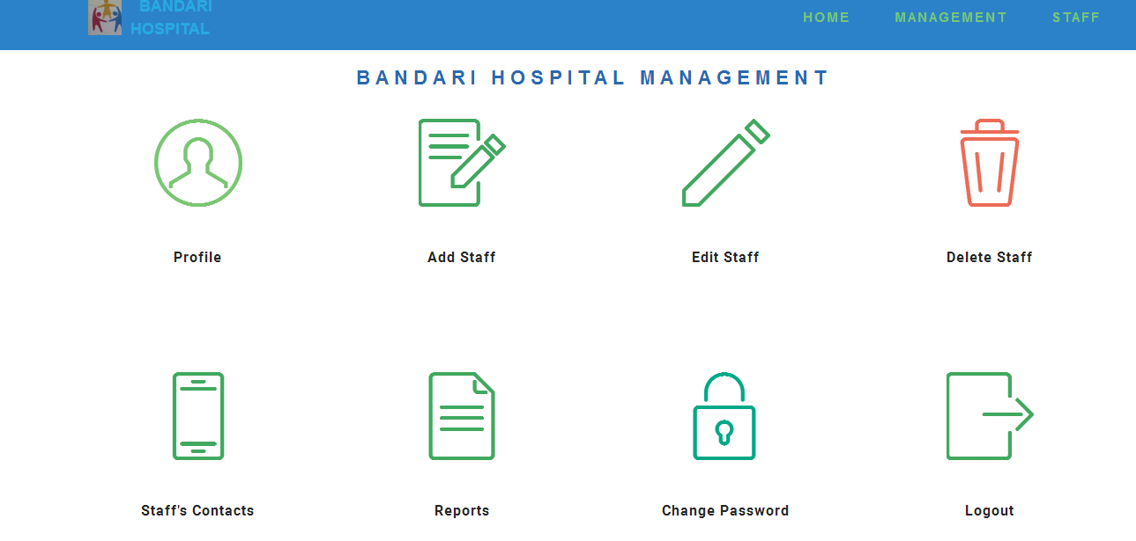

Once the management staff (Administrator) is authenticated at the login page , they are redirected to the management homepage shown above. From there , they can choose from the provided menu in the homepage the next action they want to perform .

3.STAFF LOGIN PAGE

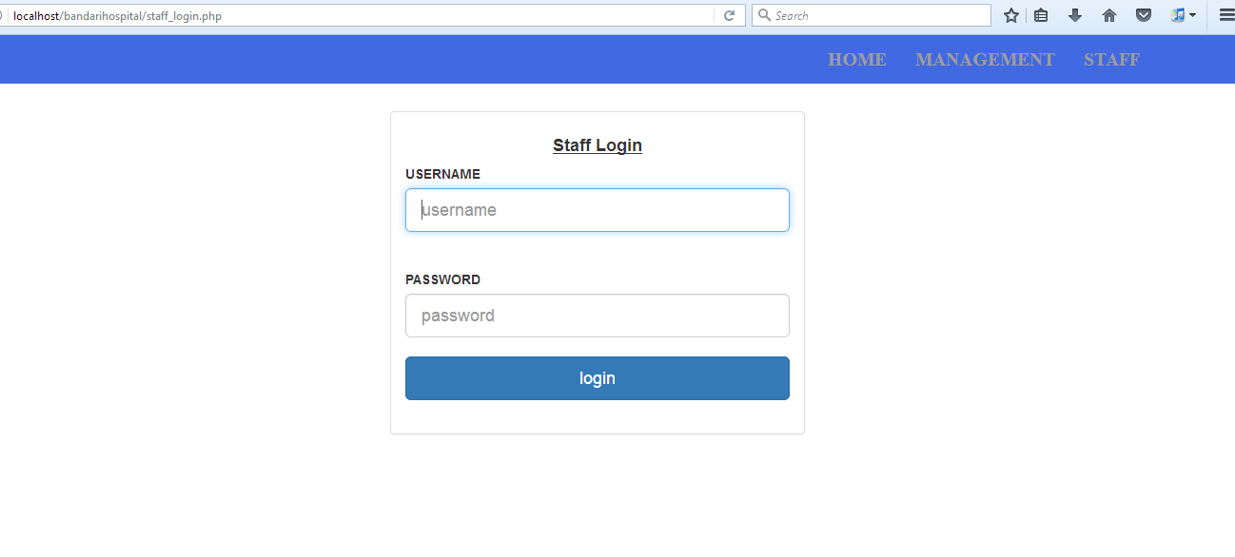

This the page that the staff is redirected after clicking “STAFF” in the navigation menu. He/ She is prompted to enter Username and Password to proceed.

4.RECEPTION STAFF HOMEPAGE

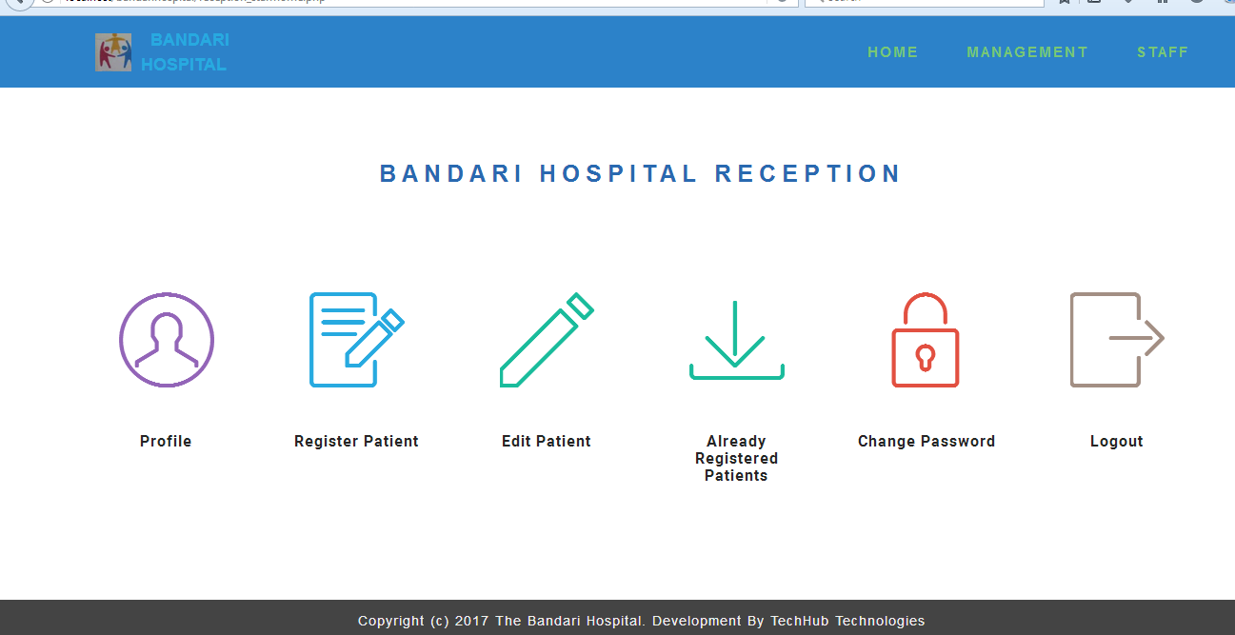

Once the reception department staff is authenticated at the login page , they are redirected to the reception homepage shown above. From there , they can choose from the provided menu in the homepage the next action they want to perform. They can Register a patient , edit a patient ,forward details of already registered patients to consultant , view their profile , change password and logout.

5.CONSULTATION STAFF HOMEPAGE.

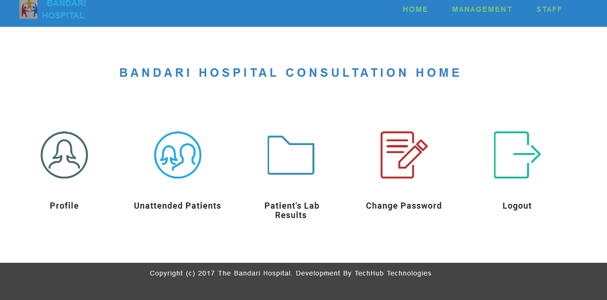

Once the consultant (Doctor) is authenticated at the login page , they are redirected to the consultation homepage shown above. The homepage provides a menu from which the doctor can choose the next action they want to perform. They can view unattended patients and attend to each , view patients lab results ,view their profile , change password and logout.

6.PHARMACY HOMEPAGE

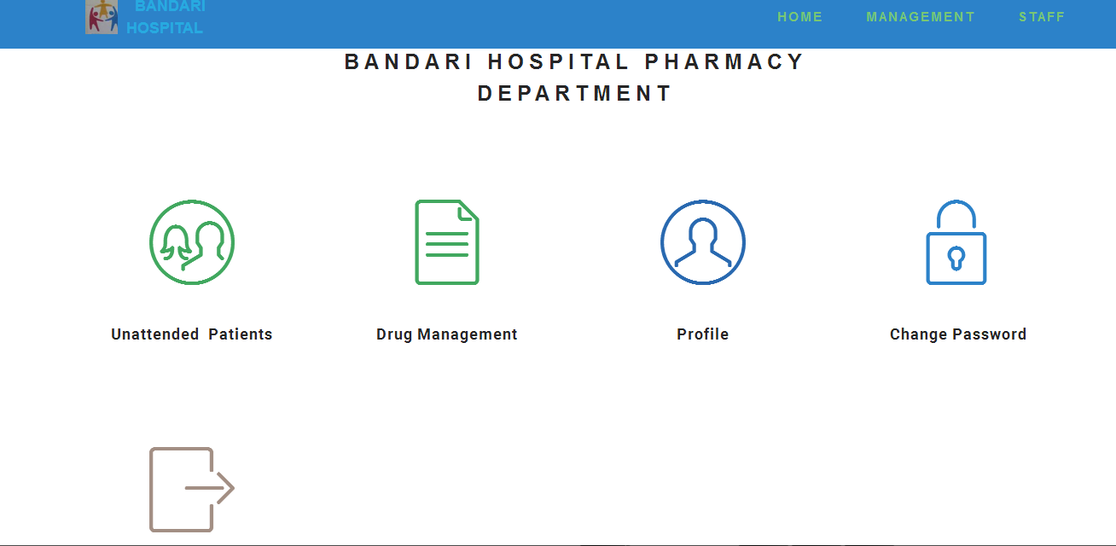

On login, the pharmacy staff is redirected to the pharmacy homepage shown above. The homepage provides a menu from which the pharmacy can choose the next action they want to perform. They can view unattended patients as posted by the doctor and attend to each , go to drug management which provides further actions, view their profile , change password and logout.

1. WARD DEPARTMENT

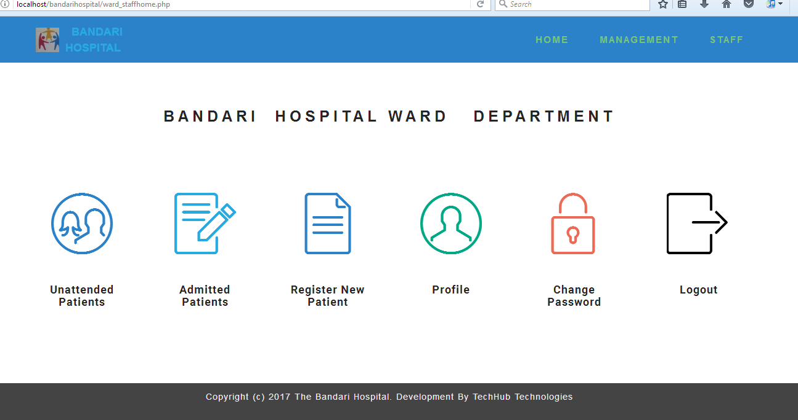

On login, the ward staff is redirected to the ward homepage shown above. The homepage provides a menu from which the ward staff can choose the next action they want to perform. They can view unattended patients as posted by the doctor and admit them, View admitted patients and discharge them, Register new patients especially emergency cases, view profile ,change password and logout.

8.LABORATORY HOMEPAGE

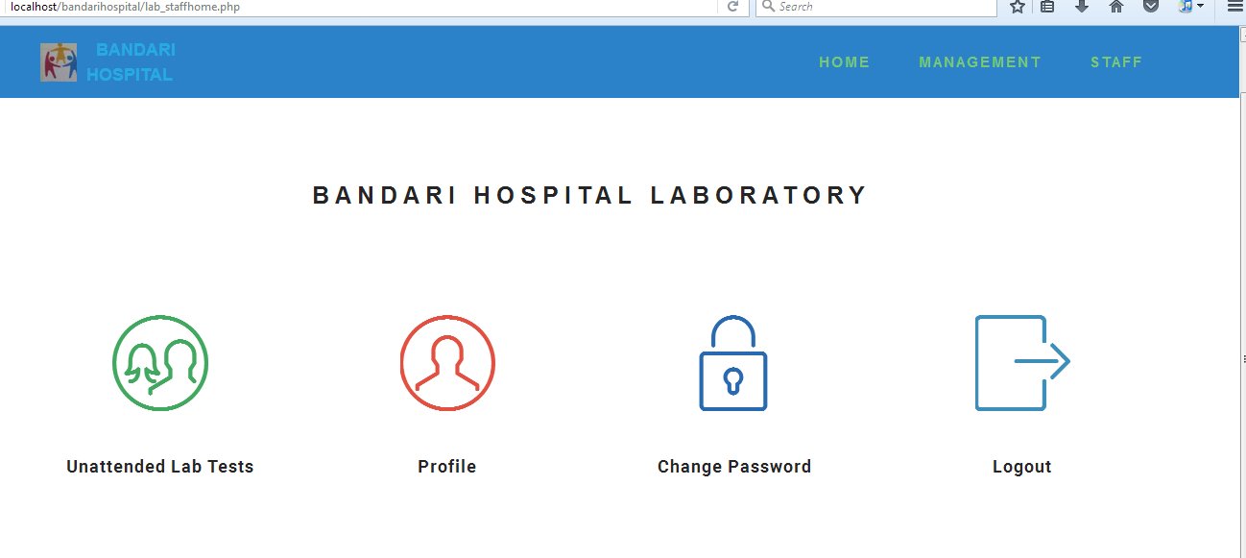

The laboratory staff is directed to the laboratory homepage shown above after login. The homepage provides a menu from which the staff can choose the next action they want to perform. They can view unattended patients as posted by the doctor , view the required tests , attend to each then post the test results back to consultant .They can also view their profile , change password and logout.

9.MORTUARY HOMEPAGE

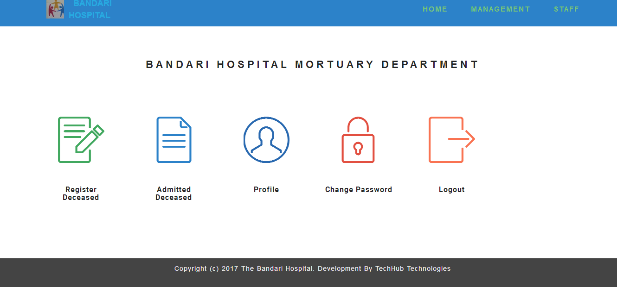

The mortuary staff is directed to the mortuary homepage shown above after login. The homepage provides a menu from which the staff can choose the next action they want to perform. They can register the deceased ,view admitted deceased and discharge them.They can also view their profile , change password and logout.

## SYSTEM DATABASE / FILE STRUCTURE PREVIEW

(i)patients_disease_record table

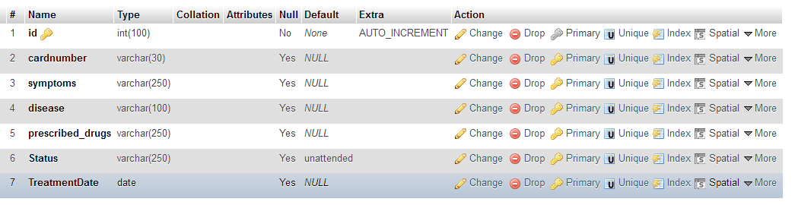

(ii)deceased table

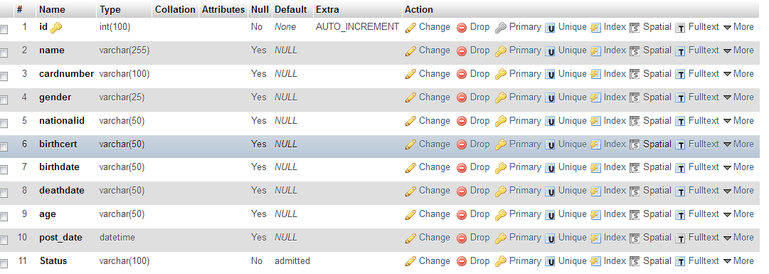

(iii)consult_ward table

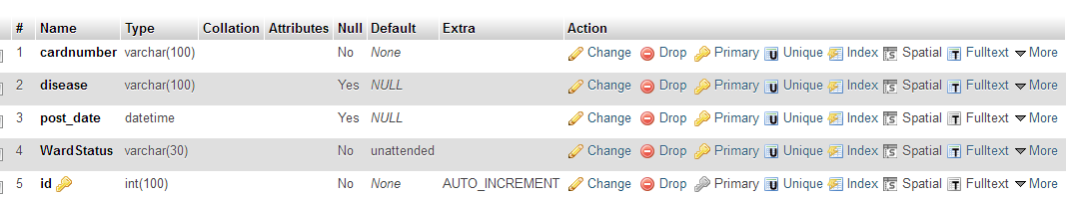

(iv) consult_pharm

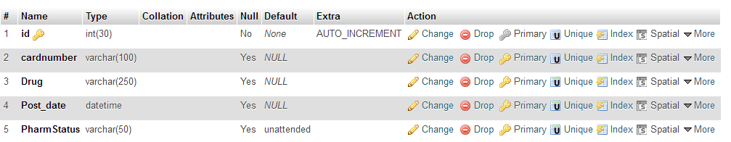

(v)alldiseases table



(vi)admitted_patients table

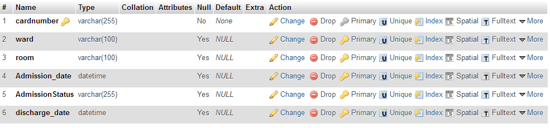

(vi)admin table

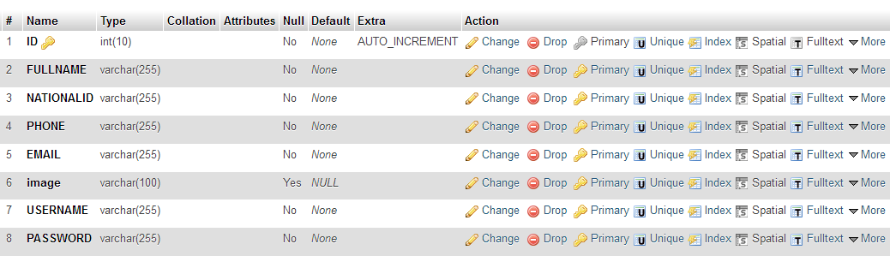

(vii) tests table

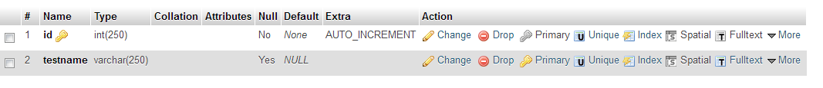

(viii) patients table

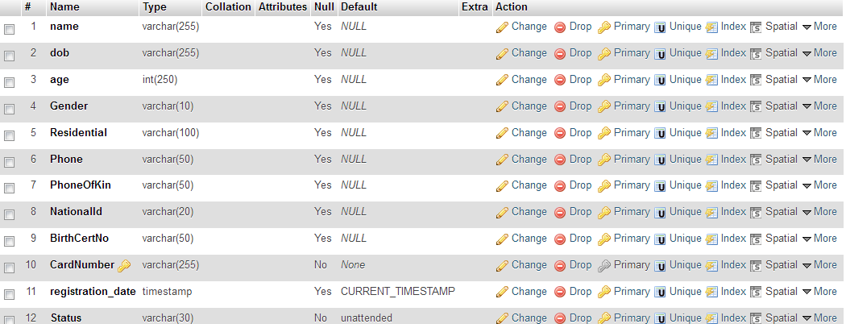

(ix)lab table

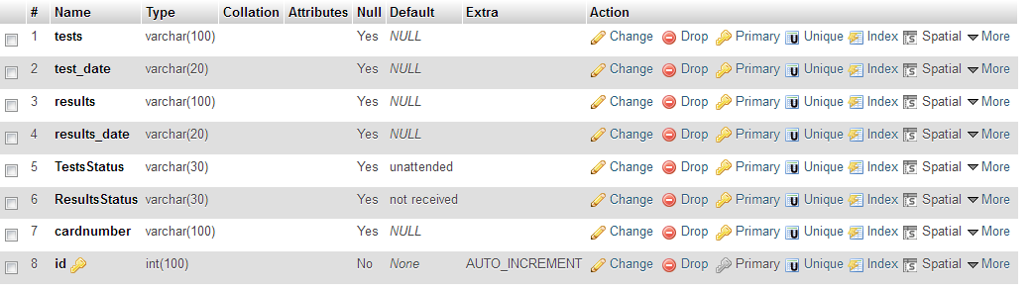

(x)drugs

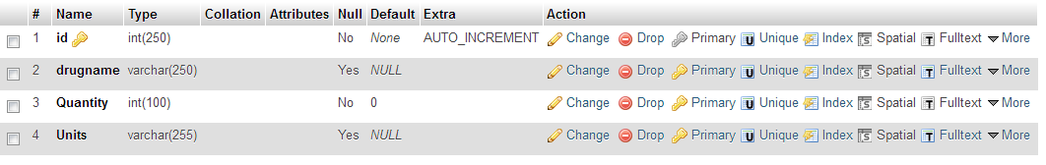

(xi)drug_issue_records table

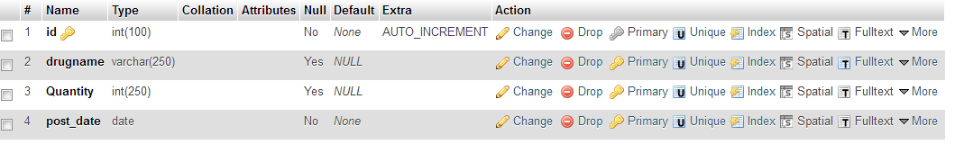

(xii)diseases table

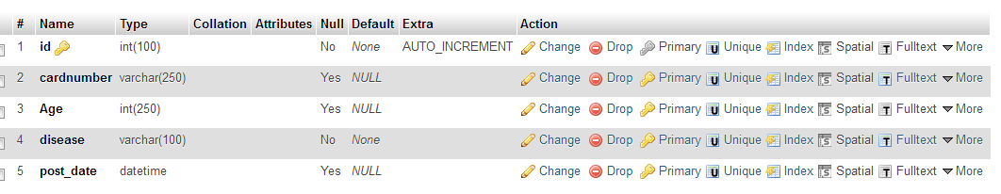

## External and Internal Limitations and Restrictions

-Login requires username and password.

-Only authenticated users can access the system

-Each operational staff is restricted to their department as they cannot login in into other departments.

## User Interface Specification

### Report formats/ Sample Data

Some of the reports generated by the system include the following:

(i)Diseases Frequency Report by date only

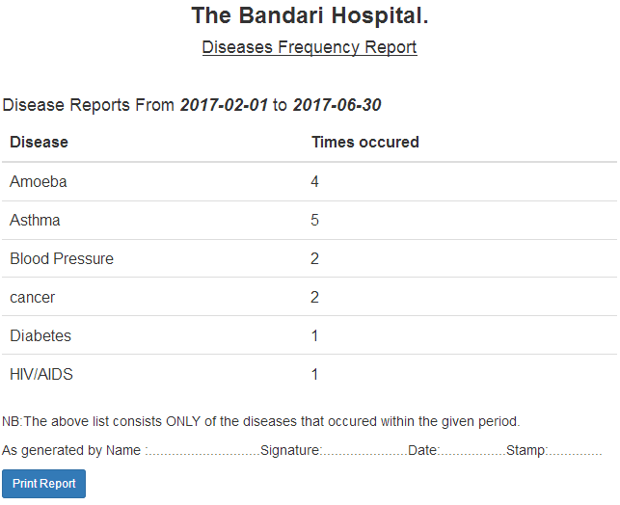

(ii)Drug Issuance Reports by date

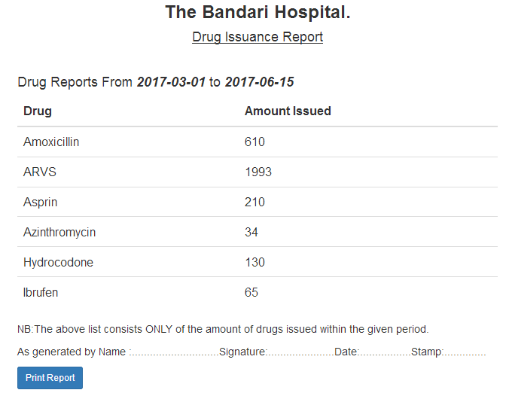

(iii)Diseases reports by date and age

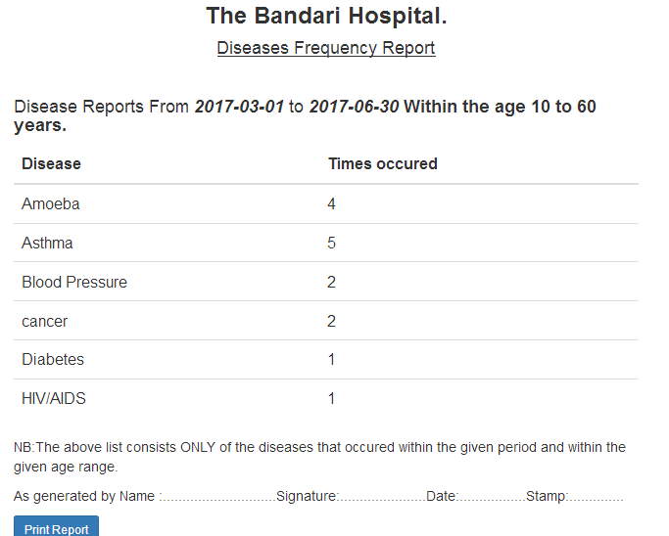

### Error conditions and system messages

The system generates error messages if an error occurs during operation. The following screenshots shows some of the error messages generated by the system.

(i)Incorrect login details

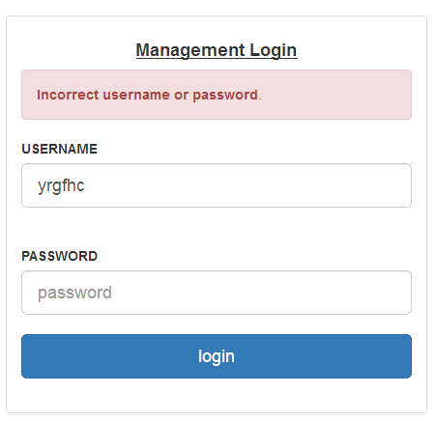

(ii)Sample registration error

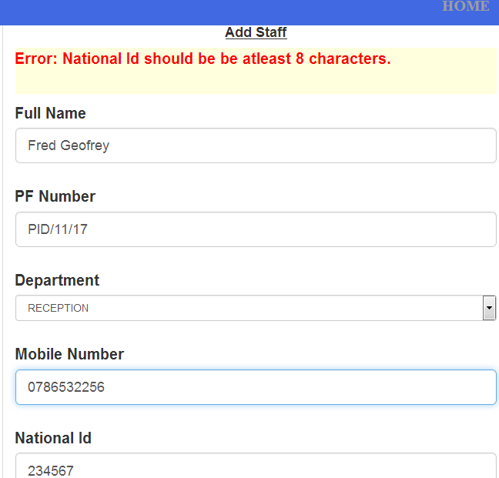

(iii) Drugs unavailable

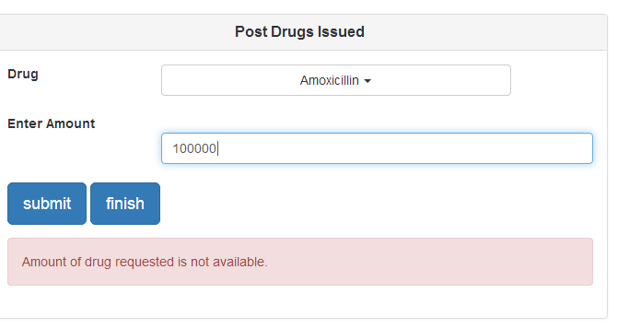

(iv)Form submission success

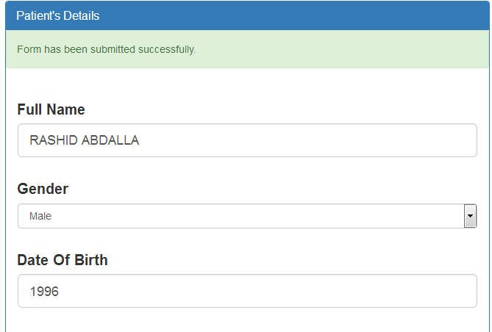

# SYSTEM PERFOMANCE REQUIREMENTS

## Efficiency

The Efficiency of Hospital Operations System is high as compared to the previous manual system where everything was done on paper work. The automated Hospital Operations System gets rid-off paper work making it efficient and faster. All the Hospital operations are computerized. Both hospital staff personnel and patient details are stored electronically including medical records and drug management records.The new system is very fast with 100% accuracy and saves time.

## Reliability

The automated Hospital Operations system is much reliable as compared to the previous manual system. The reliability of the Hospital Operations System is high since thereis proper storage of information. Accurate calculations are deduced from the database unlike the manual system where everything is stored in files and getting correct arithmetic calculations from them is a bit difficult.

## Security

### Data Security

The system also provides excellent security of data at every level of user-system interaction and also provides robust and reliable storage and backup facilities. Only authorized personnel has access to data and only authorized person can update the records.

### Execution Security/User Validation

In the Hospital Operations system User Name & Password security is implemented so that no unauthorized person can handle any operation without username and Password.

* Only authorized person can log-on the system.
* Only authorized person can update the records.
* Only authorized person can handle the reservation.
* Only authorized person can print the report.

## Maintainability

The Hospital Operations System is easy to maintain in case of any faults in the system.

## Modifiability

The Hospital Operations System is flexible therefore giving room to any modification in case new functionality is to be added to it.

## Portability

The Hospital Operations System is portable and can run in different environments like windows operating system environment, Linux or Mac OS.

# SYSTEM DESIGN OVERVIEW

## SYSTEM DATA FLOW DIAGRAMS

1. **CONTEXT LEVEL DIAGRAM**

Management

*Reception*

*Pharmacy*

*Ward*

*Consultation*

*Mortuary*

*Laboratory*

***HOSPITAL OPERATIONS SYSTEM***

1. **DFD FOR THE MANAGEMENT DEPARTMENT**

Db

Admin

1. **DFD FOR THE RECEPTION DEPARTMENT**

Receptionist

Db

Consultant

1. **DFD FOR THE CONSULTATION DEPARTMENT**

Consultant/Doctor

1. **DFD FOR THE PHARMACY DEPARTMENT**

Pharmacist

DB

DB

1. **WARD DEPARTMENT DFD**

Ward Attendant

**DB**

1. **LABORATORY DEPARTMENT DFD**

Lab Attendant

DB

* 1. **Implementation Languages**

This describes the tools used to implement the graphical user interface and the database. MySQL was used to create and connect relational tables to the database. HTML was used to develop the GUI. PHP was used to process queries and integrate interfaces was done to develop the model that meets all the requirements of this system.

**Front End**

1. Bootstrap – bootstrap is responsive, mobile-first, prevailing, and front-end framework, which is developed along with CSS, JavaScript, and HTML

* Bootstrap is extremely easy and speedy procedure to begin with and is very adaptable.
* Responsiveness – bootstrap is a great tool in creating awesome responsive websites.
* Customizable – bootstrap is easily customized as per the designs of ones` project. One makes a choice to select the aspects which are required which can be simply complete by utilizing Bootstrap customize page.

1. jQuery – is a fast, small, and feature-rich JavaScript library. It makes things like HTML document traversal and manipulation, event handling, animation, and Ajax much simpler with an easy-to-use API that works across a multitude of browsers. The three main advantages of jQuery are: its light weight when compared to other JavaScript frameworks. It has a wide range of plugins available for various specific needs. It is easier for a designer to learn jQuery as it uses familiar CSS syntax.
2. jQuery UI – It is a set of curated set of user interface interactions, effects,widgets, and themes built on top of the jQuery JavaScript Library. It is used in building highly interactive web applications for example by adding a date picker to form control.

**Back End**

1. PHP – is a server-side web programming language widely used for web development. In the Hospital Operations System, PHP was used to process queries and integration of interfaces to develop a model that meets all the requirements of the system. PHP can run on both UNIX and Windows Servers.
2. MySQL – We used MySQL at the back-end to create and connect relational tables to the database.MySQL provides efficient/effective solution for major database projects and has the following advantages:

* Large database and space management.
* Many concurrent database users.
* High transaction processing requirement
* High Availability
* Industry accepted standards
* Manageable security
* Portability

1. **SYSTEM DATA STRUCTURE SPECIFICATIONS** 
   1. **User Input Specification** 
      1. **Identification of Input Data**

Input data for the system in subclassed into 7 categories;

(i) Registration input data

This is data that is input in account registration forms, this could be either registration of an admin account, a doctor account or a operational staff account.

(ii)Login input data

This is data that is input to login into an already registered account.

(iii) Diagnosis Input Data

This is the data that the doctor records about the patients diagnosis.

(iv)Prescription input data

This is the data that the doctor records about the the drugs that the pharmacist will issue to the patient.

(v)Patient Tests Input Data

This is the data that the doctor records about the patients’ tests will the laboratory staff will perfom.

(vii) Patients results input data

This is the data that the laboratory operational staff records about the results of the corresponding lab tests.

(viii)Drug Records Input Data

This is input data that the pharmacist records about drugs issued to patients ,new drugs and drug amount updates.

* + 1. **Source of Input Data (NOT input device)**

The sources of the systems input data are the management(admin) and the operational staff (doctors).

1. **Management (Admin)**

The admin performs input of data such as registration of the doctors.

(ii)**Operational staff (doctors)**

The operational staff in the different departments performs input of patients data into the system . For example information on patients diagnosis , patients registration , drugs issued to patients etc.

* + 1. **Input Medium and/or Device**

The input device for the data input into the system is the keyboard or any other device that is an equivalent of the keyboard.

* + 1. **Data Format/Syntax**

All the Systems Registration Forms input data has the following format

The forms input fields which must be filled include Name(characters) ,E-mail(valid email address), Passwords(alphanumeric characters) , LabTests , Lab Results , Drugs and Diagnosis all characters.

* 1. **User Output Specification** 
     1. ***Identification of Output Data***

Output data is obtained after input data is provided and thus the subclasses are also 7;

(i)Registration Output Data

This is data that is output after the Sign Up button is clicked during account registration.

(ii)Login Output Data

This is data that is output after the Sign In button is clicked during account login.

* + 1. ***Output Device/ medium***

The output device of the data can be any device/screen that has a browser that has access to internet

* + 1. ***Output Format/Syntax***

-In every output subclass there are two kinds of output;standard output (successful form submission)and standard error(unsuccessful form submission).

-If a query to the database is run successfully ,the requested data is displayed if available otherwise a meassage is displayed to indicate that the data is not available.

* 1. **System Data Base/File Structure Specification** 
     1. ***Identification of Data Base/Files***

The Bandari Hospital Operations System uses MariaDB/MySql database management .The systems has a single database named bandari with fourteen tables in it;

admin- Admin data

staff- Staff data

patients – Patients personal information

admitted_patients- admitted patients data

deceased- The deceased personal data

diseases- contains a list of all diseases suffered by patients as recorded by doctor after diagnosis.

alldiseases – contains a list of all common diseases.

lab –contains both lab tests and results for the patients.

Tests –contains a list of all tests carried out in the laboratory.

drug_issue_records- contains a record of all drugs issued to patients

patients_disease-record – contains a record of patients disease and prescribed drugs records.

Drugs- contains a record of all drugs available in the hospital and their quantity.

consultpharm – contains patients information posted by the doctor to the pharmacy department.

consultward –contains information posted by the doctor to the ward department.

* + 1. ***(Sub)systems Accessing the Data Base***

(i)Creating

Registration subsystems

* Staff Registration

*Patient registration

(ii) Updating

*Details update for both staff and patients.

(iii) Using Login subsystems

* + 1. ***Logical File Structure***

The logical file structure of the database is managed by the InnoDB storage engine.

Record Format

The record/row format used in the tables in the database is the compact row format.

You can get this using the following query;

SELECT * FROM INFORMATION_SCHEMA.INNODB_SYS_TABLES;

In this format BLOB and TEXT columns are partly stored in the row page. At least 767 bytes are stored in the row; values which exceed this value are are stored in dedicated pages.

File organisation

Logical file organisation is done through per-table tablespaces.A tablespace is a logical group of one or more files in a database.InnoDB stores the data and indexes for each table in a separate .ibd file, eg.admin.ibd,

Access Methods

In databases using innoDB storage engine data is accessed from table asynchronously(where possible) or sequentially.

* + 1. ***Physical File Structure***

**Storage Device**

Physical files(.ibd and .frm) files are stored in a directory name bandari in the physical storage/ harddrive of the computer hosting the Bandari web system.

**File organisation**

The physical files that collective form a logical database are stored in a folder named bandari which contains .frm and .ibd files.The .frm files contain information regarding the structure of the tables in the database like rows and columns, headers etc while the .ibd files contain the actual data and indexes.The db.opt file contains contains basic cofiguration options like the default-character-set and default-collation.

6.3.5 Data Base Management Subsystems Used

Database management subsystem is a system that connects to the database and performs insert, update,delete or select operations on data.

1. **MODULE DESIGN SPECIFICATION**
   1. **RECEPTION MODULE**
      1. ***MODULE FUNCTIONAL SPECIFICATION***

**Functions Performed**

The main functionality of the reception module is patients’ registration. When the patient visits the hospital the receptionist registers him/her by storing the details to the Hospital Operations System database. The patient details stored include patient name, age, next of kin details, National Id number, Birth Certificate number and it is at this point that the patient is issued a unique card number to uniquely identify him or her in the system.

If the patient had previously been registered to the system there is no need for a second registration, the receptionist just forwards the patient to the doctor for consultation and diagnosis.

**Module Interface Specifications**

**Module Limitations and Restrictions**

* + 1. **Module Operational Specification**

**Description of Module Operation**

The Reception Module is operated by the receptionist. The receptionist logs into the module to access its menu. After log in he or she can carry out the module operations i.e. Registering a new patient or by referring already registered patient to the consultation department by unsetting patients’ status to unattended.

* 1. **CONSULTATION MODULE**
     1. ***MODULE FUNCTIONAL SPECIFICATION***

**Functions Performed**

The Consultation module has several functionalities. At first the consultation confirms the patients’ registration and if the patient is not registered he or she is sent back to the receptionist for registration. The consultant also views unattended patients, select one of the patients and attend to him or her. During consultation, the module have several menus performing different functionalities:

* Diagnosis Menu – Allows doctor to diagnose the patient.
* Pharmacy Menu – Allows the doctor to refer the patient to the pharmacist by forwarding patient details and the drugs to be issued to the patient.
* Ward Menu – Allows the doctor to post details of a patient to the ward department in case the patient requires to be admitted.
* Laboratory Menu – Allows the doctor to post tests to be performed to the patient by posting the tests to the laboratory and also viewing the posted results from the tests carried out.

**Module Interface Specifications**

**Module Limitations and Restrictions**

* + 1. **Module Operational Specification**

**Description of Module Operation**

The Consultation module carries out several operations. For a doctor to access different menus of the consultation menu, he or she has to log into the system first. After logging in the doctor gets access to the different menus of the module. The doctor then can diagnose the patient, refer him or her to the pharmacist to be issued drugs or refer the patient to the laboratory for tests or admit the patient for special treatment in the ward. The doctor can also view posted results from tests carried out in the laboratory.

* 1. **LABORATORY MODULE**
     1. **MODULE FUNCTIONAL SPECIFICATION**

**Functions Performed**

The Laboratory Module performs mainly two functions:

* **Viewing tests** – The module allows laboratory attendant to view tests posted by the Consultant/Doctor that are to be carried out on a specific patient.
* **Posting Results** – The module also allows the laboratory attendant to post lab results back to the consultation after carrying out tests.

**Module Interface Specifications**

**Module Limitations and Restrictions**

* + 1. **Module Operational Specification**

**Description of Module Operation**

The laboratory model perform several operations also. The laboratory attendant logs into the system in order to access the module menus. After log in, the laboratory attendant can view posted tests by the doctor and carry out the tests. The attendant also posts the results of the specified tests back to the consultation.

* 1. **PHARMACY MODULE**
     1. **MODULE FUNCTIONAL SPECIFICATION**

**Functions Performed**

The pharmacy module performs several functionalities:

* **Drug Management** – The module allows the pharmacist to manage drugs within the system. In cases where a new drug is brought to the hospital, it is registered by the pharmacist. In case of already registered drug the pharmacist just updates the quantity of the drug in the system by keying in the new quantity brought.
* **Issued drugs to patients**– The pharmacy module allows the pharmacist to view the drugs specified by the doctor to be issued to the patient and issue them and also record the issued drugs.

**Module Interface Specifications**

**Module Limitations and Restrictions**

* + 1. **Module Operational Specification**

**Description of Module Operation**

The pharmacist model allows several operations to be undertaken. Just like the other modules, the pharmacist has to log into the module for him or her to access its menus. Once the pharmacist is logged into the module, he or she can perform different operations of the module like drug management where registration of a new drug is done or quantity of an existing drug is updated. The module also allows the pharmacist to view and issue drugs to a patient as specified by the doctor.

* 1. **WARD MODULE**
     1. **MODULE FUNCTIONAL SPECIFICATION**

**Functions Performed**

The ward module performs several functions. It allows the ward attendant to carry out the following functionalities:

* View patients to be admitted as posted by the doctor
* Admitting the patient by allocating them specific rooms
* Discharging the patient when discharging time comes.

**Module Interface Specifications**

**Module Limitations and Restrictions**

* + 1. **Module Operational Specification**

**Description of Module Operation**

The ward module performs several operations. Ward attendant logs into the module in order to access the module menus. When logged in, ward attendant can view patients to be admitted and allocates rooms to them. The module also gives the ward attendant a room or chance to discharge an admitted patient.

1. **SYSTEM TESTING AND VALIDATION**

Testing was done after the system was put in place. This was done in two ways: Implementation and Unit testing was carried out on individual modules of the system to ensure that they are fully functional units. We did this by examining each unit which we checked to ensure that it functions as required and that it adds clients‟ data and other details and also ensured that this data is sent to the database. The success of each individual unit gave us the go ahead to carryout integration testing. All identified errors were dealt with.

We carried out integration and system testing after different modules had been put together to make a complete system. Integration was aimed at ensuring that modules are compatible and they can be integrated to form a complete working system. For example we tested to ensure that when a user is logged in, he/she is linked to the appropriate page, and could at the same time access the database. As one of the final specific objectives of this study, validation of the system was very important. Validation of the system was done by comparing it to user questions. Most of their answers matched what the system can do.

1. **CONCLUSIONS**
   1. SUMMARY

The project **Hospital Operations System (HOS)** is for computerizing the working in a hospital. The software takes care of all the requirements of an average hospital and is capable to provide easy and effective storage of information related to patients that come up to the hospital.It is capable of forwarding patients information from one department to the other.

It generates drug and disease reports; provide prescription details including various tests

and medicines prescribed to patient by doctor. It provides a patients treatment history including the diseases the patient suffered , signs and symptoms and drugs issued. The system also takes care of information related to the operational staff and management staff.

* 1. PROBLEMS ENCOUNTERED AND SOLVED.
  2. FUTURE EXTENSIONS TO PROJECT

-Introduction of patients module where they can view treatment history by their own.

-Integration with sms API that will enable users /patients to report emergency cases to the hospital. The hospital can thus take action to save the patient.

-Integration with a module that stores all patients details including details on the next visit .When the next visit date nears , the system sends automatic messages reminding patients that they have to see their doctor.

-Integration with a billing and accounting module to manage the hospitals finance department.

1. **BIBLIOGRAPHY**

**[1]** Elmarsi Navathe and Addision Wesley (2015) **Fundamentals of Database System** ,Seventh Edition.

**[2]** Ian Somerville (2007)**Software Engineering**, Eigth Edition, Pearson Education.

[3] Welling ,Luke and Thomson ,Laura (2008).PHP and MySQL Web Development , Third Edition

Web References.

[www.google.com](http://www.google.com)

D